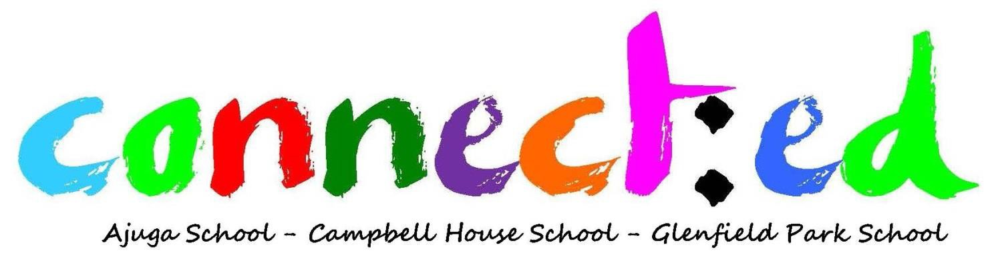

Information
2017
Semester 1

Introduction
Ajuga, Campbell House and Glenfield Park Schools have a connect:ed program which comprises parents, carers, family and friends who meet regularly and who work with school personnel on programmes and projects that will benefit themselves and students. The purpose of connect:ed is to strengthen the cohesion between our community and the educational process.

When you attend the connect:ed you become part of a network of parents, carers and other community members who work in partnership with the school. Communication is a two-way process which benefits the student, their parents/carers and the school. Your involvement in their school sends a clear message to your child of your interest in their education, which will encourage them to adopt a more positive attitude towards learning. With your involvement, your child will be more motivated, have better attendance and participation in learning and school activities.

You will be better able to support and guide your child if you are well-informed about what is going on in your child’s school. By attending connect:ed, you will also gain the support from other members of our community through this network. When schools and parents/carers work together, they complement each other’s strengths and gain a common vision towards improving the school – all for the betterment of your child’s education.

What?
connect:ed has been designed to create positive educational connections between parents, carers, students and staff.

Who?
connect:ed is facilitated by the staff of Ajuga School, Campbell House School and Glenfield Park School and community members.

Where?
connect:ed is held on the school grounds either in the Heritage Room or location appropriate for the activity. These are specified on the attached calendars. Morning tea is provided and pick up from the train station is available. Please call your school office if required on Ajuga 9827 6100, Campbell House 9827 6160 and Glenfield Park 9827 6120.

When?
connect:ed is on each Tuesday from 10am to 12pm. Reminders are sent out in the previous week. You can also keep up-to-date using your school’s website, Facebook page or Twitter (where available).

Why?
The advantages of attending connect:ed are many. It is a friendly way to get to know other parents and carers whom you may have much in common with and are able to share your experiences and ideas. It also connects you with the school and the staff as well as improving the students’ self-esteem.

TERM 1 | DATE | TIME | ACTIVITY | WHO | VENUE
Week 1 | 24/1/17 |  | School Holidays – no activity
Week 2 | 31/1/17 | 10am | Meet & Greet Morning Tea | Jo Lewis  Chris Walker  Susan Harlow | Heritage Room
Week 3 | 7/2/17 | 10am | How can Centrelink help | TBC | Flexible Learning Space - Ajuga
Week 4 | 14/2/17 | 10am | All things legal | Mark Hankin | Flexible Learning Space - Ajuga
Week 5 | 21/2/17 | 9.30am | Barefoot Bowls | Jo Lewis  Chris Walker  Susan Harlow | Cabramatta Bowling Club
Week 6 | 28/2/17 | 10am | Pilates | Claudia | Heritage Room/Gym
Week 7 | 7/3/17 | 9.30am | Walk & Talk | Jo Lewis  Chris Walker  Susan Harlow | TBC
Week 8 | 14/3/17 | 10am | Arts & Crafts | Jo Lewis  Chris Walker  Susan Harlow | Heritage Room
Week 9 | 21/3/17 | 10am | Gentle exercise | TBC | Heritage Room/Gym
Week 10 | 28/3/17 | 9.30am | Do it yourself | Jo Lewis  Chris Walker  Susan Harlow | Bunnings
Week 11 | 4/4/17 | 10am | End of term morning tea | Jo Lewis  Chris Walker  Susan Harlow | Heritage Room/Gym

TERM 2 | DATE | TIME | ACTIVITY | WHO | VENUE
Week 1 | 25/4/17 |  | Anzac Day -  no activity
Week 2 | 2/5/17 | 10am | Meet & Greet Morning Tea | Jo Lewis  Chris Walker  Susan Harlow | Heritage Room
Week 3 | 9/5/17 | 10am | Nest – The Nutrition Education Sustenance Training Program | TBC | Heritage Room
Week 4 | 16/5/17 | 10am | Nest – The Nutrition Education Sustenance Training Program | TBC | Heritage Room
Week 5 | 23/5/17 | 9.30am | Nest – The Nutrition Education Sustenance Training Program | TBC | Heritage Room
Week 6 | 30/5/17 | 10am | Nest – The Nutrition Education Sustenance Training Program | TBC | Heritage Room
Week 7 | 6/6/17 | 9.30am | Nest – The Nutrition Education Sustenance Training Program | TBC | Heritage Room
Week 8 | 13/6/17 | 10am | Pilates | Claudia | Heritage Room/Gym
Week 9 | 20/6/17 | 9.30am | Do it yourself | Jo Lewis  Chris Walker  Susan Harlow | Bunnings
Week 10 | 28/3/17 | 10am | End of term morning tea | Jo Lewis  Chris Walker  Susan Harlow | Heritage Room/Gym

